 | জাতীয় বিশ্ববিদ্যালয়  National University Bangladesh

Project Report on

Inframote (IR Remote Application)

Submitted to:
The Controller of the Examinations
National University Bangladesh
Gazipur-1704, Bangladesh

Supervised By:
Mr. Mohammad Ariful Hyder
Professor
Department of Computer Science and Engineering
Dhaka City College

Prepared By:
Prince Billy Graham Karmoker  Registration Number: 16502000458  Session: 2016-17  Bachelor of Computer Science and Engineering  Dhaka City College (NU-6408) | Ahesanul Karim Abid  Registration Number: 16502000521  Session: 2016-17  Bachelor of Computer Science and Engineering  Dhaka City College (NU-6408)


Dhaka City College
(ESTD. 1957)
Road No. 2, Dhanmondi Residential Area, Dhaka-1205, Bangladesh
www.dhakacitycollege.edu.bd
Date of submission: 15/12/2021

Letter of Testimonial

5th December 2021
To The Controller of the Examinations
National University Gazipur-1704, Bangladesh

Subject: Submission of project report on “Inframote (IR Remote Application)”

Dear Sir,
This is to inform you that my report on the project "Inframote (IR Remote Application)" has been completed.

I followed the instructions of my institution's supervisor while also attempting to follow the guidelines provided by you in preparing this project. However, this has equipped me with a lot of experience that will help me perform similar projects in the future. I'd like to thank you, as well as my supervisor and department, for their assistance and advice in preparing the report, presentation and project.

If you require any extra information regarding this report, I will be happy to supply it. Thank you very much.

Sincerely yours,
(Prince Billy Graham Karmoker)
Registration Number: 16502000458
Session: 2016-17
Computer Science and Engineering
Dhaka City College (NU-6408)
email: princebillygk@gmail.com
(Ahesanul Karim Abid)
Registration Number: 16502000521
Session: 2016-17
Computer Science and Engineering
Dhaka City College (NU-6408)

Declaration

I solemnly declare that the work described in this project report, titled "Inframote (IR Remote application)," was completed under the direction of Md. Ariful Hyder, Department of Computer Science and Engineering, Dhaka City College, Bangladesh. It has never been submitted to another university, college, or organization for any academic qualification, certificate, diploma, or degree. I have not violated on any existing copyright, and no part of this report has been plagiarized from previous work done for a degree or other purposes.
(Prince Billy Graham Karmoker)
Registration Number: 16502000458
Session: 2016-17
Computer Science and Engineering
Dhaka City College (NU-6408)
email: princebillygk@gmail.com
(Ahesanul Karim Abid)
Registration Number: 16502000521
Session: 2016-17
Computer Science and Engineering
Dhaka City College (NU-6408)

Acknowledgment

To begin, I would want to offer my heartfelt gratitude to Almighty God for providing me with the opportunity to finish my project report in a very convenient manner.

Mr. Mohammad Ariful Hyder, Professor of Computer Science and Engineering Department at Dhaka City College, is my esteemed supervisor, and I owe him my gratitude and thanks. He worked with me throughout the process of finishing my project. His guidance improved my confidence and enabled me to complete my studies and project on schedule. I'm also grateful to my department head, as well as all of the professors and seniors who helped me along the way by mentoring us and reviewing my work.

Finally, I would like to express my gratitude to all who have read this report and will benefit from it in the future.
(Prince Billy Graham Karmoker)
Registration Number: 16502000458
Session: 2016-17
Computer Science and Engineering
Dhaka City College (NU-6408)
email: princebillygk@gmail.com
(Ahesanul Karim Abid)
Registration Number: 16502000521
Session: 2016-17
Computer Science and Engineering
Dhaka City College (NU-6408)

Table of Contents
Chapter 1 | Introduction 1
1.1 Introduction 1
1.1.1 Motivation 1
1.2 limitation of existing system 1
1.2.1 Available apps 1
1.3 Proposed System 2
1.3.1 Business Model 3
1.3.2 Project Layout 3
1.4 Conclusion 4
Chapter 2 | Background Study 1
2.1 Introduction 1
2.2 Infrared Remote controller system 1
2.2.1 Infrared Radiation (IR) 1
2.2.2 What is IR Remote controller system? 1
2.2.3 Why IR Remotes are so popular? 2
2.2.4 Limitation of IR Remote Control System? 2
2.2.5 Working principal of IR Remote 2
2.2.6 Modulation and encoding techniques 3
2.2.7 Macro command 4
2.3 Software Development 5
2.3.1 Software Requirement Specification 5
Chapter 3 | Software Requirement specification (SRS) 1
3.1 Introduction 1
3.2 Use Case Diagram 1
3.2.1 Actors 1
3.2.2 System & Goals 1

Introduction

Introduction
Infrared signals are being used by most remote-controlled gadgets (such as TVs, DVD players, and air conditioners) to connect with the host device because they consume minimum power and work over a short distance. Some recent smartphones include an infrared blaster that can act as a remote control. However, without this feature, infrared signals can be made utilizing the headphone jack/USB port and an IR transmitter LED that can interface with the smartphone to generate required IR signals.
Some apps (MI Remote, Zaza Remote, and so on) have been already developed to control this IR blaster, but only a few of them support the workaround I have mentioned. Sadly, I was unable to locate any apps that allow users to contribute or create custom remotes. I also discovered that none of them support the local branded devices (such as Minister, Vision, Defender, Walton).
To resolve these issues, I propose to develop a new Android app called InfraMote. InfraMote will be a free app for Android users who would like to utilize their phone as a IR remote controller to manage their TV, fan, light, or air conditioner, or any other electronic equipment. This app will address all of the flaws mentioned above.

Motivation
The project will enable me to gain knowledge and experience in a variety of computer science and engineering fields, including server management, database management, backend technology, REST API, android application development, microelectronics, embedded systems, digital signal processing, SDLC (Software development life cycle), project management, documentation writing, and presentation skills.
I want to add this project to my portfolio, use the gathered knowledge and experience to land my ideal job, and start my own business with this knowledge and expertise. However, with the help of Google Ads and the Google Play store, the end product of the project may be able to generate a considerable amount of revenue; if this is the case, I would like to improve the features of the service and offer a more acceptable and upgraded product under this domain.
Last but not least, everyone, including myself, will be able to enjoy a new Android application with local remote support, which excludes the drawbacks described in the previous section.

limitation of existing system
I've reviewed and tested a number of apps that allow you to control an IR transmitter or IR blaster that are already available in the Android app store.

Available apps
Here is a list of apps that I have reviewed:

MI Remote Controller (Xiaomi Inc)
Play store Rating: 4.1 (Recorded in 9 December 2021)

Notable Feature:
- Friendly UI

Limitations
- Does not have a lots of remote
- Does not have local branded remotes (Vision, Minister, etc.)
- No Customization
- Supports only few android devices
- Requires internet for adding new remote configuration
- Drains a lot of power
- Does not support user contribution

ZaZa Remote (Tiqiaa Co. Ltd)
Play store Rating: 4.2 (Recorded in 9 December 2021)

Notable Feature
- Supports a large number of remote
- Supports DIY remote control using headphone jack and IR Transmitter LED
- Usable with Alexa

Limitations
- Does not have local remotes
- No Customization
- Requires internet for adding new remote configuration
- Does not support user contribution

More similar remote apps:
Lean Remote (Lean remote) - Rating 4.3, Broadlink Universal TV Remote (Broadlink) - Ratting 4.5

Summary of limitation in existing system vs Inframote
Features | MI Remote Controller | Zaza Remote | Others | Inframote
Allows contribution | ✖ | ✖ | ✖ | ✔
Supports external receiver | ✖ | ✖ | ✖ | ✔
Ability to create custom remote | ✖ | ✖ | ⚠ | ✔
Supports local device | ✖ | ✖ | ⚠ | ✔
Friendly UI | ✔ | ✖ | ✖ | ✔

Proposed System
- The proposed system is an Android app that solves all the issues discussed in 1.2. I have pointed out the goals here:
  - Creating an IR remote android application that solves all the limitations below:
  - Allows contribution from users
  - Has supports for all Local Brands
  - Has supports for External/DIY IR Transmitter device
  - Has ability to create custom remote using the app
  - Has ability to record IR signals
- Creating a central API and database that will be responsible for managing remote and users data
- Prototyping an IR receiver model to collect and decode IR signal from existing remotes

Business Model
I'll utilize Google Ads to monetize this Android app and cover the costs of the server and database. The app will be proprietary. Ad-free access is available to remote contributors and premium users.

- Ad-free experience for premium users
- Ad-free experience for contributors
- Regular users who are neither premium users nor contributors will have to watch Google ads to use the application

Project Layout
This project is divided into 3 major segments.
\Database & API
This is the heart of the software, and it's in charge of managing user and remote data. The RESTFUL API will interface with the database, the Android app, and any third-party services (e.g., Oauth), and will include documentation for developers to create applications that use the API.
Database model design
Database relational
RESTFUL API
Testing and optimizing
API documentation

Android application (APP)
This is the end-user product that allows regular people to access and use the service. For the time being, I will exclusively work on the Android platform due to its popularity, availability, and low development cost.
- UI design
- API Integration
- Google Ads Integration
- Testing and optimizing
- Deploy to Marketplace

Electronics & Hardware Segment
- This segment's final product will be an electric gadget that can interpret IR signals from remote controls and feed data to the app.
- Prototype using simulation software
- Prototype using breadboard
- Programming
- Testing
- Prototype using Veroboard
- PCB design and 3D modeling
- Soldering and mounting components to PCB
- Enclosure design and 3D modeling
- Assembling

Conclusion
This chapter provides a comprehensive outline of the planning as well as an overview of the project. The goal and motivation for developing the proposed system have been detailed here. I'll go over My previous knowledge and the background research I'll need to complete this assignment successfully in the upcoming chapter.

Background Study

Introduction
I've provided notes regarding the background studies, which are essential to working on this project, in this chapter. I attempted to explain how the Infrared Remote Controller System works, as well as how the web server, database, and Android application are coupled and can be used in this project. The majority of the information was acquired and analyzed from several websites and a few textbooks. In the reference area, you'll find all those website URLs and books' titles with their authors’ names.

Infrared Remote controller system
I've provided notes regarding the background studies, which are essential to work on this project, in this chapter. I attempted to explain how the Infrared Remote Controller System works, as well as how the web server, database, and Android application are coupled and can be used in this project. The majority of the information was acquired and analyzed from several websites and a few textbooks. In the reference area, you'll find all those website URLs and books' titles with their authors’ names.

Infrared Radiation (IR)
According to Wikipedia,
“Infrared, sometimes called infrared light, is electromagnetic radiation with wavelengths longer than those of visible light. It is therefore invisible to the human eye. IR is generally understood to encompass wavelengths from around 1 millimeter to the nominal red edge of the visible spectrum, around 700 nanometers.”
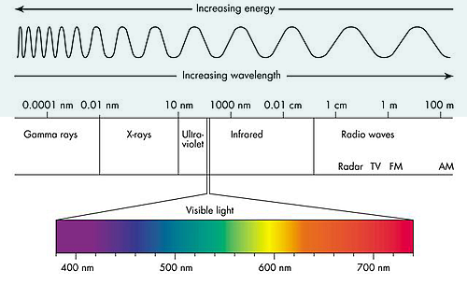Figure 2.1: Wavelengths of electromagnetic spectrum.

What is IR Remote controller system?
The IR remote converts digital signals into infrared light signals, which it then sends by flashing a specific LED (IR Transmitter) capable of emitting infrared light. Using an IR receiver, the controlled device receives the signal and decodes it into digital signals that the internal microprocessor can understand and execute the instructions from the signal.

Why IR Remotes are so popular?
IR remotes are found in almost every home appliances, including televisions, air conditioners, lights, fans, and speakers. Since the day it was discovered, it has become increasingly popular. This technology has a number of advantages, which are listed below:
- Power efficient
- Wireless communication system
- Inexpensive to manufacture
- Because of the short range, it's safe
- The signal is undetectable to the naked eyes
- Remote controls are physically smaller in size

Limitation of IR Remote Control System
Despite the fact that this communication system has so many advantages. The following are some of the limitations of the IR Signal:
- Only works within a certain range of distance (about 30 feet)
- Can’t pass through walls
- It's possible that it'll interfere with other gadgets in the area
- It may be affected by direct sunlight or other light sources that emit infrared radiation
- Transmission rate is slow.

Working principal of IR Remote
When we push a button on the IR remote, it makes contact with the printed wires beneath it, completing a circuit that the integrated chip on the remote recognizes, and the remote then sends a binary/digital instruction through the IR LED. According to the voltage provided by the integrated chip, the LED transmits a series of light pulses.

Modulation
The IR LED emits infrared light when it receives a modulated signal from the transmitter micro controller unit. Modulation assist in the isolation of the actual signal from the noise.

Demodulation
The IR light is converted to an electric current by a photo diode in the receiver. A transimpedance amplifier is used to convert the current to a voltage. The voltage is amplified, filtered, and demodulated before being used as an input by the receiver micro-controller unit.

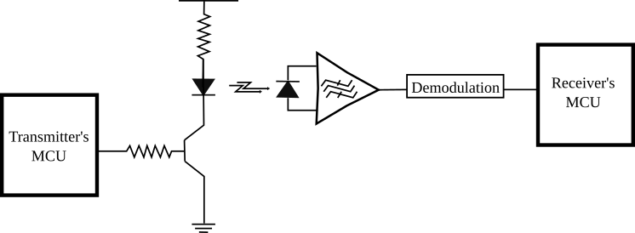Figure 2.2: Infrared signal modulation and demodulation

Modulation and encoding techniques

Amplitude Shift Keying (ASK) Modulation
The Amplitude Shift Key is abbreviated as ASK. Because of its high performance, simplicity, and low cost, it is a widely common modulation technique across industries. The receiver and transmitter's carrier are tuned to the same frequency in this method, which is commonly 30, 33, 36, 38, 40, or 58 kHz.
There are different types of encoding in ASK modulation
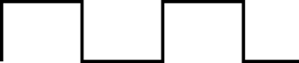Figure 2.4: Actual Signal
Figure 2.3: ASK Modulated Signal

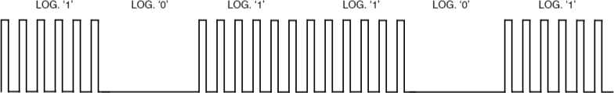Figure 2.5: Pulse Position Encoding

Pulse

Position encoding
- Constant width for each bit
- Modulated pulse represents logic 1
- Space represents 0

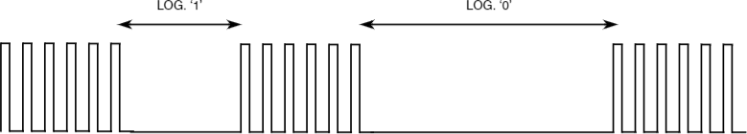Figure 2.6: Pulse Distance Encoding

Pulse

Distance encoding
- Space width distinguish between logic 0 and 1
- composed of spaces and pulse

Figure 2.7: Manchester Encoding

Manchester Encoding
- modulated pulse to space means logic 1
- spaces to modulated pulse means logic 0
- constant width for each bit

Frequency Shift Keying (FSK) Modulation
Different frequencies are used for different logic levels in FSK modulation. In FSK modulation, there are no intervals between the modulated pulses.

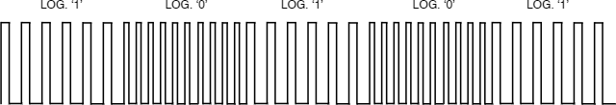Figure 2.8: Frequency Shift Keying (FSK)

Macro command
It's a set of commands that we can pre-program to run sequentially and deliver with a single button press.

Software Development

Software Requirement Specification

Different types of Users
End User | The one who uses the product or service.
Stakeholder | The one who is affected by the product by any means
Stakeholder | Primary User | End user of the product
Stakeholder | Secondary User | The one who will use the app occasionally or use it through intermediary
Tertiary User | The one who will affected by the use of product or make discussion about the product.

Types of Requirements
Business Requirement | Defines the purpose of the project
Business Rule | Defines the budget guidelines and regulation. (eg. Legal Regulation, Privacy policies)
User Requirement | Task that user can accomplish with the product: Generally defined with: Use cases, User stories, Story Boards, Scenarios
Functional Requirement | Generally defined using information flow diagram to define the behavior of the product.
Non-Functional  Requirement | Defines the following characteristics of the each task:  - Accuracy  - Dependability  - Usability  - Security  - Efficiency  - Performance  - Maintainability
External Interfaces | External Parameters that will affect the development of the product (eg. External API, Database etc). Data flow diagram can be used to show the relation of external interface
Physical product settings | Physical parameters that will influence the product
Development  Constraints | Production Environment (Bandwidth, Processing Power, Memory, Platform, Environment)

Steps for collecting and documenting Software requirement

(STEP 1) Eliciting Requirement
- Meeting, discussion and collaboration with clients
- Distinguish wants and needs
- Check if the requirements are realistic and feasible

Tools & diagrams used here:
- Use case diagram (Preferred software: Draw.io Desktop)
- Wire-frame (Preferred software: Figma Desktop)
- Story Board (Draw.io/Figma)

(STEP 2) Expressing Requirements
- Framing the requirement
- Writing user stories

Tools & diagrams used here:
- Backlog
- Story Map

(STEP 3) Prioritizing Requirements
Prioritizing the user stories in the backlog by their importance in the following criteria:
- Must be done
- Should be done
- Could be done
- Won’t be done

Tools & diagrams used here:
- Backlog

(STEP 4) Analyzing Requirements
Check the documented requirements to make sure the requirements have the following characteristics
- Correct (Accurate)
- Complete (No Missing Information)
- Clear (No Ambiguity)
- Consistent (No Conflict)
- Feasible (Possible To Implement)
- Traceable (Trackable)

(STEP 4) Managing Requirements
- Tracking and managing changes
- Update requirements

Software Requirement specification (SRS)

Introduction
The description of what the system should accomplish, the service or services it delivers, and the constraints are all included in the system requirement. This chapter covers the requirements for the system I'll be working on over the next several days. All of the activities that the program will be able to do, as well as their input and output, are specified here. I've listed all of the hardware and software interfaces, as well as the expected reaction times for each activity, how error monitoring will be handled, the system's expected maintainability, what critical information need to protect, the security level, and any other constraints.

Use Case Diagram
In a system, a use case diagram is used to show distinct actors and their tasks. Use case diagrams assist in recognizing how various types of users will interact with and benefit from the program. It creates a link between each task and its user. A use case diagram helps in the identification of software requirements. Figure 3.1 shows the use case diagram for this application.

Actors
The various categories of app users are referred to as actors. The sign 웃 (Stick Man) denotes an actor in use case diagram. Below is a quick overview of the actors involved in this system:

Consumer
The term "Consumer" refers to an Inframote Android application user who uses the app on a regular basis. In fact, it refers to a user who will get this software from the app store, install it on their phone, and utilize it to get the most out of it by using various remotes.

Account holder
The word "account holder" refers to the app's users who will register and create a user account in order to have an impact on our system (such as contributing and reporting) and store their data in the cloud.

Contributor
By making a contribution to this app, an "account holder" can become a "contributor." A contributor can create, manage, and share their own remotes.

System & Goals
The Inframote Remote Application is the system in this scenario. A rectangle and a title are used to identify the system in use case diagram.
Goals are several tasks that a user can perform by using the application. The goals are represented by a circular box with the goal written inside.

Wireframe
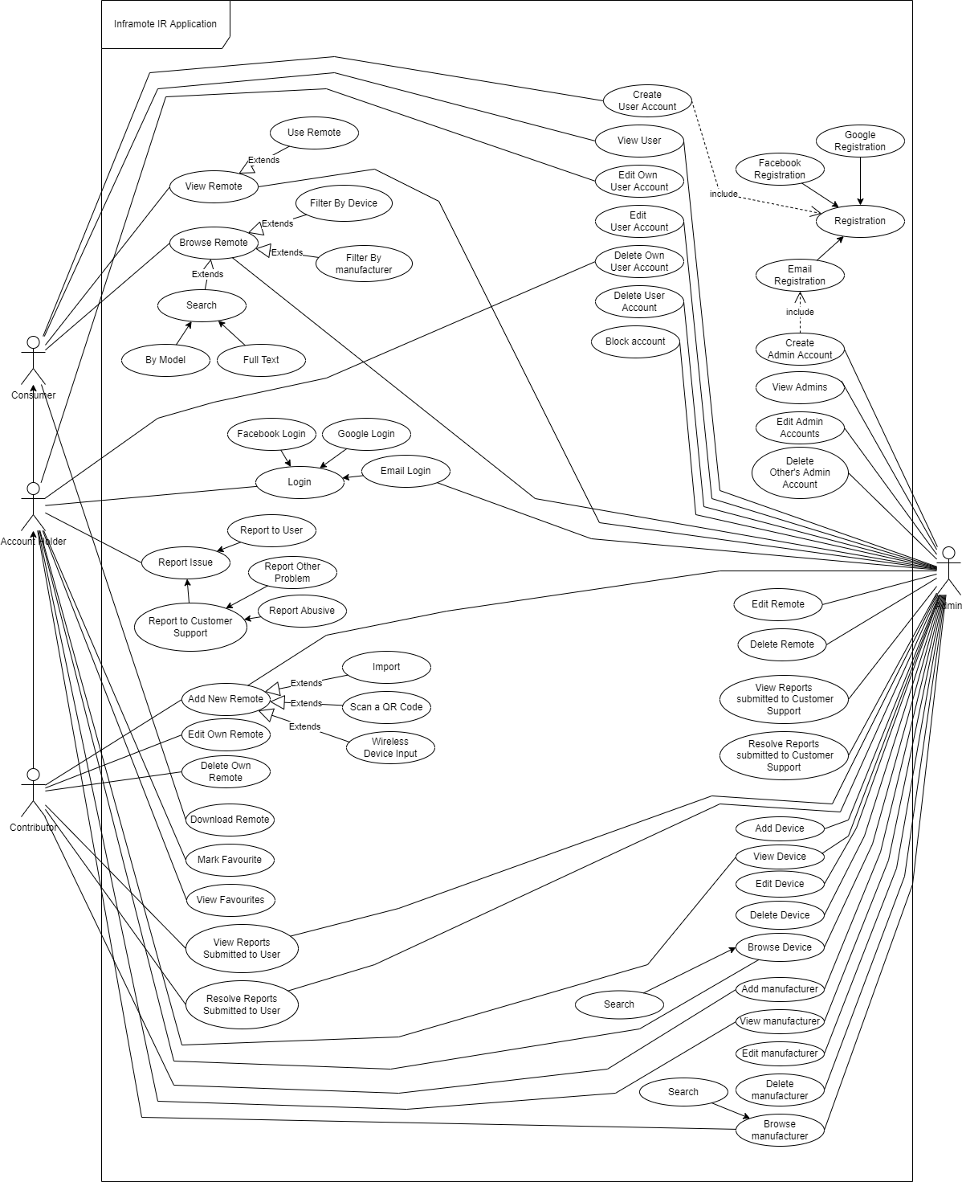Figure 3.1: Use Case Diagram for Inframote

